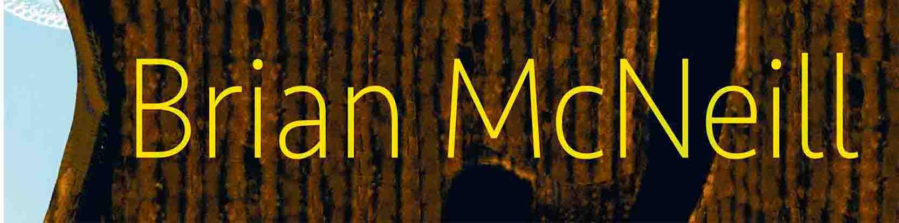

Brian’s Website

brianebmcneill@gmail.com

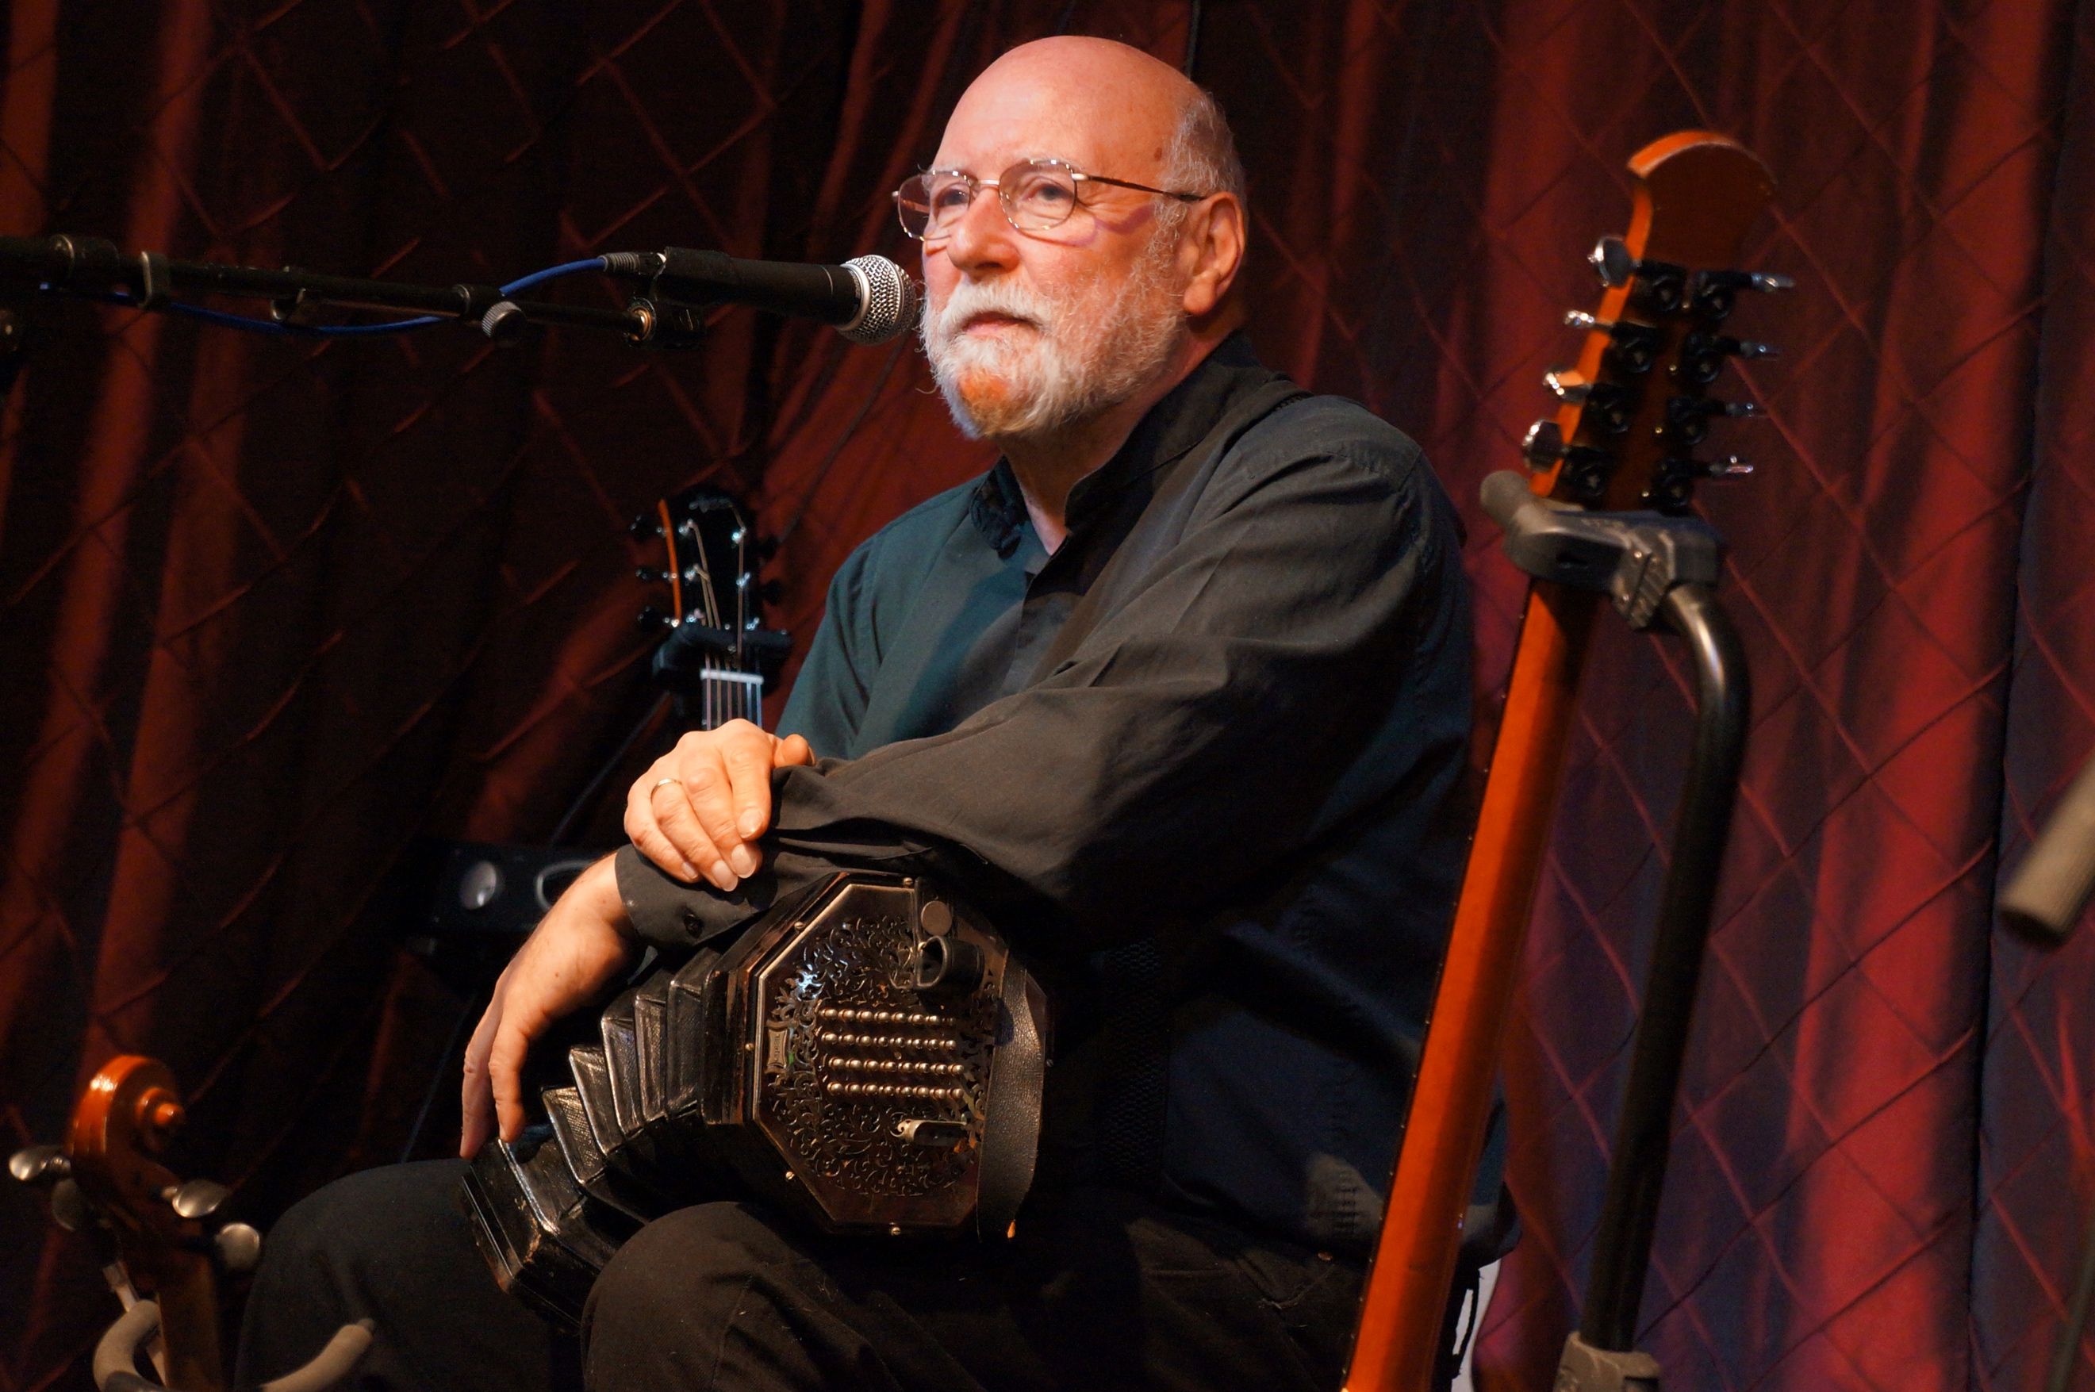

Greetings and I hope all is well with you and yours.

I’m delighted to report that my novels, including the whole of the Busker series (to date) and The 90th Kill, are now available in paperback from the website above. To mark their launch, they are available at the following rates:

1 novel: £10 + £6 p&p
2 or 3 novels: £9 each + £8 p&p
4 or 5 novels: £8 each + £16 p&p (two packages)

To protect the books they would be sent no more than three per package.

Please note that this offer applies only to orders from my website and not to novels, in either eBook or paperback format, from the Kindle or Amazon website.

Now, much though it disappoints me to say so, if you live outside the UK, I am not recommending that you buy direct from me. Rises in overseas postage rates have made things very expensive, so if you don't live in the UK, I would suggest you buy from Amazon. Also, leaving the EU has made sending items there complicated, with possible costs to the recipient on receipt of their parcel. Therefore, until things become clearer - and hopefully better - only one novel per package will be sent to the EU. I’ll be happy to sign anything you bring along to a gig - should anything as exotic as live performance be on the horizon - and of course should you really want a signed or dedicated copy and can bear the cost, I'm very happy to oblige. One idea I’m working on is a signed/dedicated label or bookmark for your book. I’ll keep you informed.

These are the overseas p&p charges for one novel:

EU and non EU Europe: £11
USA: £22
Canada: £17
Australia: £20

If you would like your book/s autographed, and/or dedicated, please indicate this with your order. If you would like a specific dedication, please make sure you let me know exactly what it is.

Don't forget that my CDs are also available from the website. I haven't made them part of this offer because I won't undercut my great record labels, Greentrax and FMS.

Here are the books.
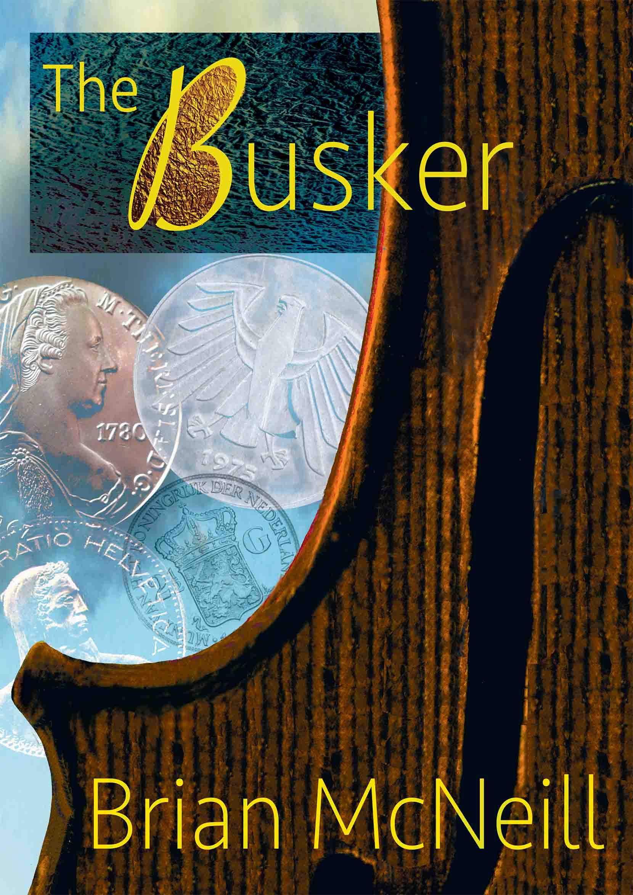
THE BUSKER
Book 1 of the Busker Series

Alex Fraser is a rootless drifter who lives by playing Scotland’s traditional music on the street. He makes his home wherever his fiddle might earn him a few coins. He’s a man hiding from life, haunted by the death of his wife, which he caused. After serving his sentence in Scotland, he decides to try his luck in Europe.
In Switzerland he befriends another busker—Max, an old accordionist. Max tells him a story, a puzzle rooted in the Spanish Civil War. It’s a tale of kindness and brutality, involving a German intelligence unit, a rescued child, a painting and a huge inheritance. Max, dying, charges Alex with solving the puzzle.
The maelstrom of violence and greed he uncovers is byzantine, daunting and ruthless. It pursues him across a continent, makes him confront love again, and ultimately forces him to believe in his own worth as a human being.
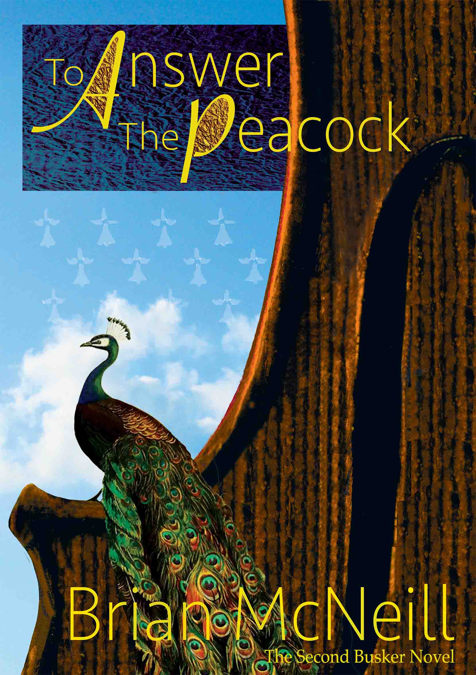
TO ANSWER THE PEACOCK
Book 2 of the Busker Series

Alex Fraser is in Rennes, in Brittany. While busking, he’s accosted by a mad beggar. The episode ends with his violin in pieces and him being worked over in a police station.
But it gets worse. Suddenly he’s a target. Why? And why would anyone want to steal his clapped-out car? Or pursue him at night through the port of Concarneau?
Or plant a priceless antique violin in his battered fiddle case, in place of his own wrecked instrument?
The mysteries intensify against the web of conspiracy spun round Nathalie Gwer-nig, the beautiful daughter of a dead Breton nationalist hero. Torn between his grow-ing love for her and his need to find his own fiddle, Alex finds himself unravelling the hypocrisies of an English stately home, fighting ancient rural cruelty, and being pursued by both authority and a deadly political extremist.
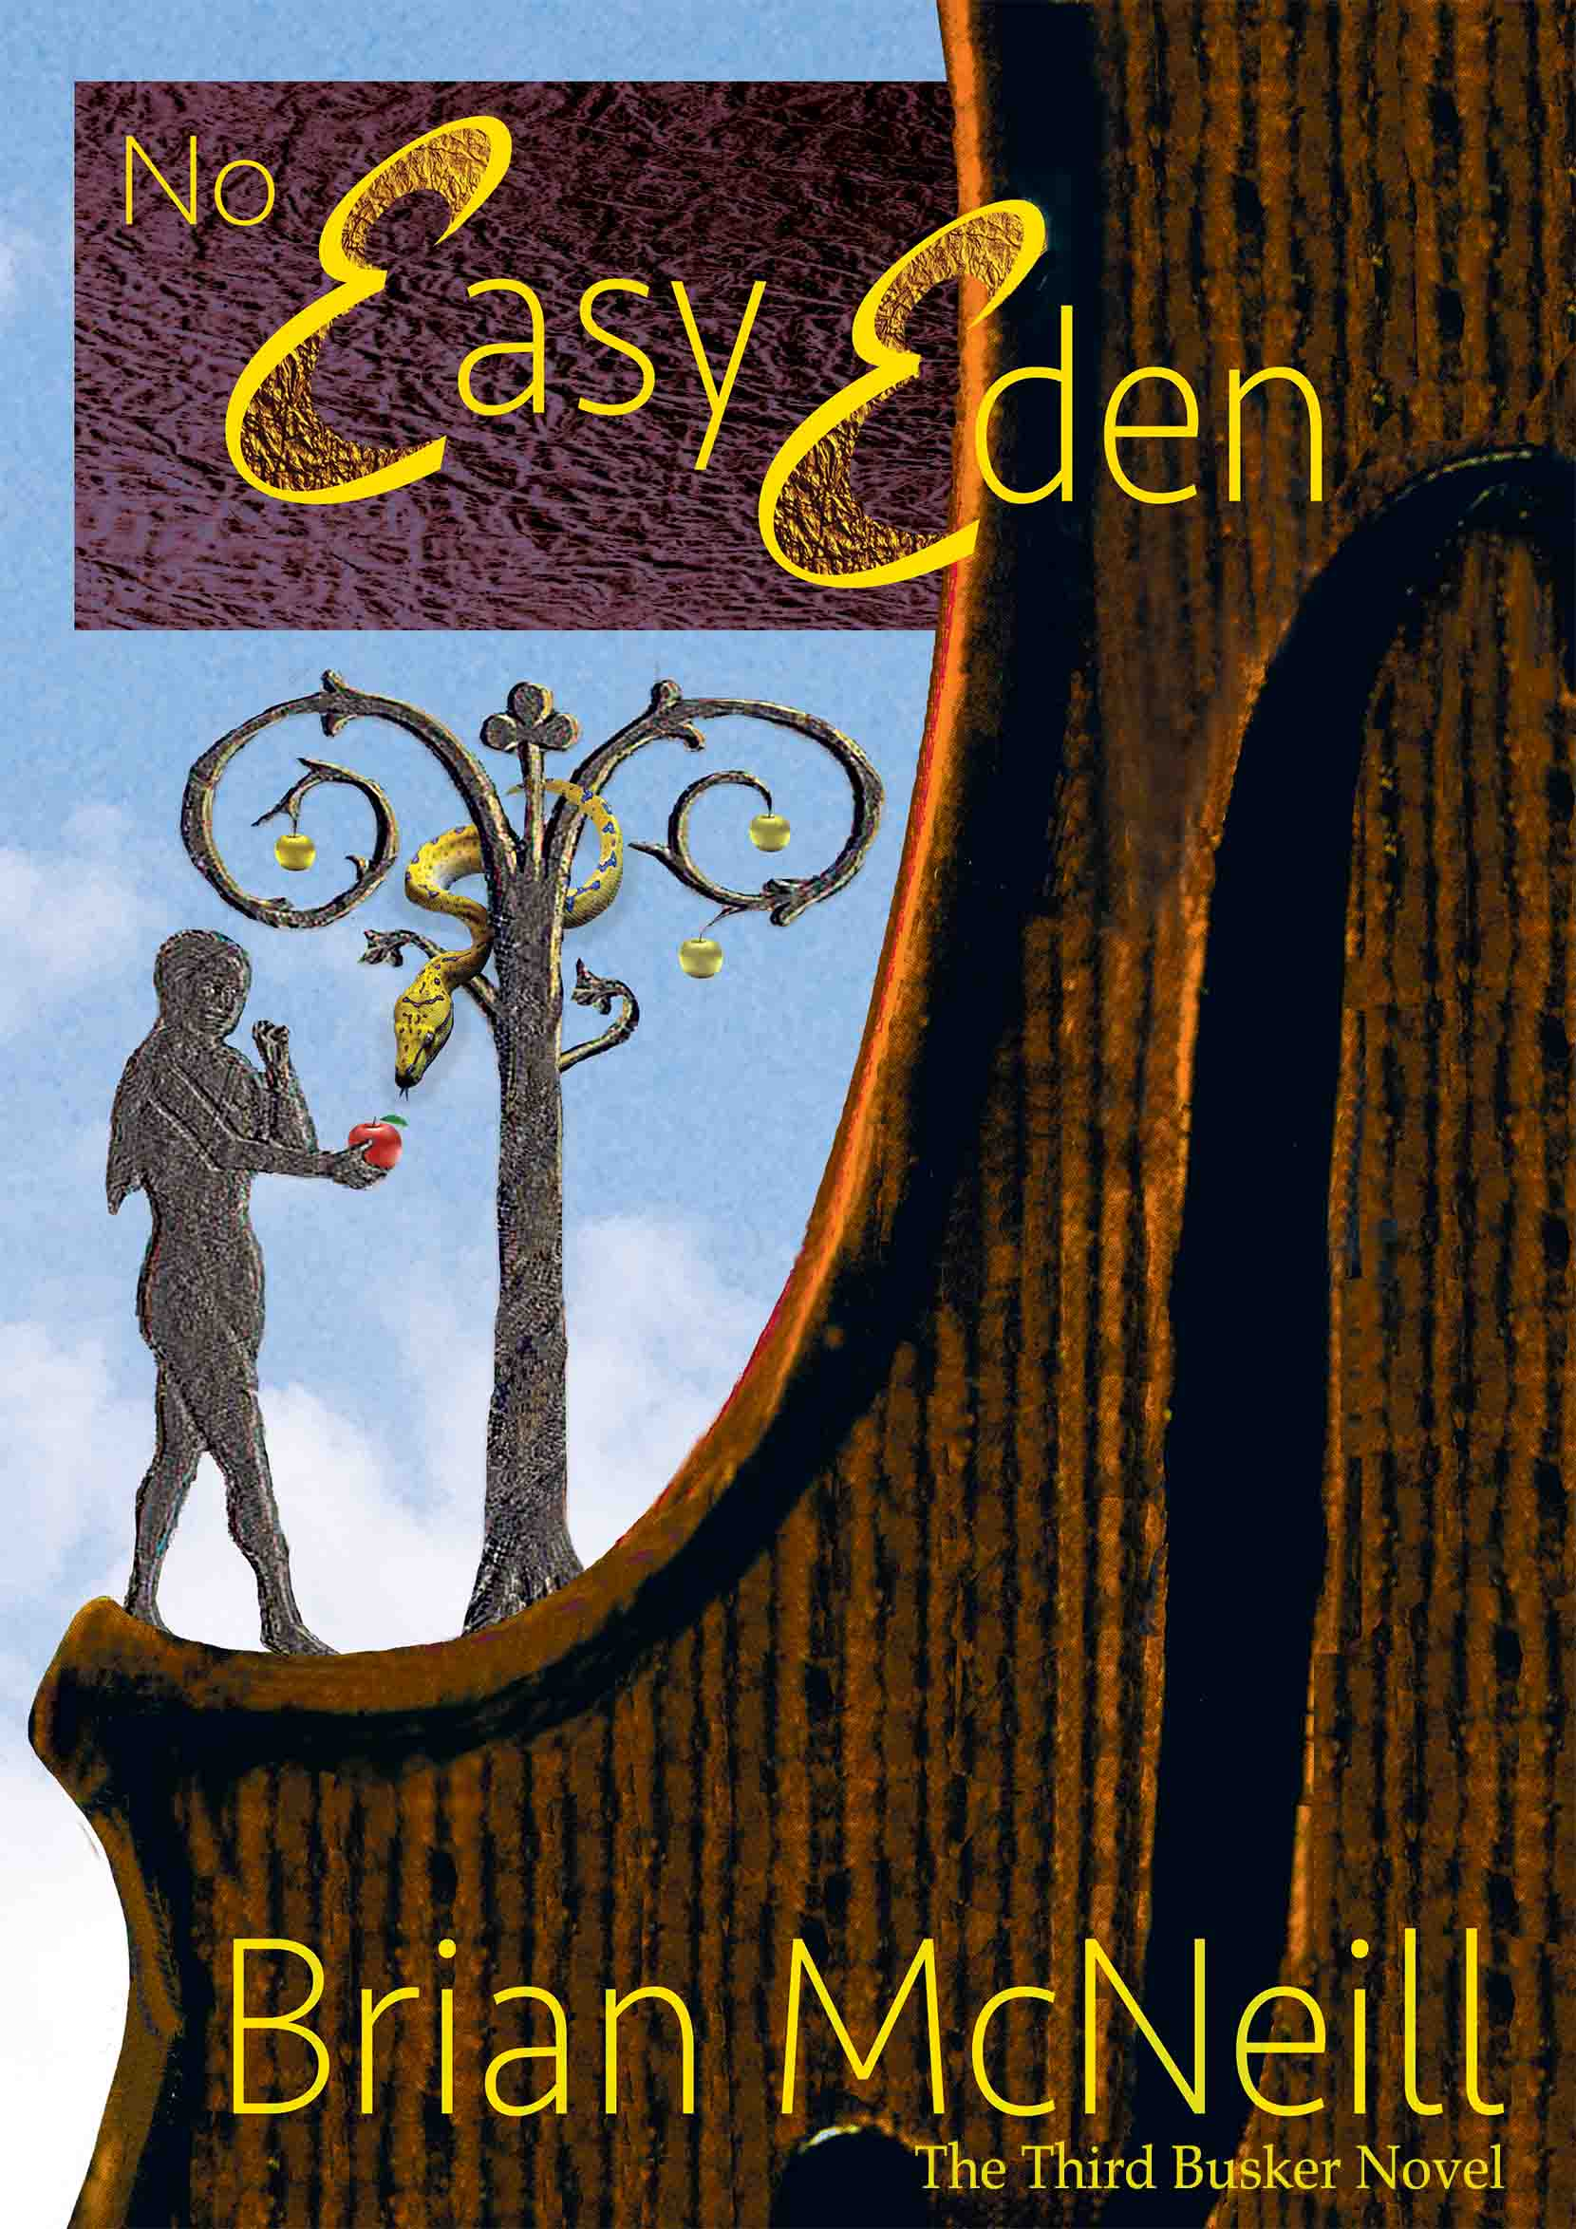
Finally, his quest takes him back to Scotland. It forces him to revisit his past, before ending in a bloody confrontation on a Hebridean island.
NO EASY EDEN
Book 3 of the Busker Series

In Germany, Alex is given a lift by Abigail Eve, a black US Air Force captain. They stop at a fast food restaurant in the town of Rothenburg. A few minutes later, three junkies come in. After creating a scene, the kids run off, followed by a concerned nun, and then as Alex and Abigail leave, a bomb explodes, killing her and hospitalising him. He wakes to find Gunther Klein, a reporter, at his bedside.
After Alex is discharged, Klein investigates. Who was the nun? Why were the junkies in the restaurant? To keep Alex safe, Klein sends him to his ex-wife Sigi’s family, but when Alex discovers Sigi is part of what happened—and that the US military want to arrest him—he flees. In Rothenburg train station, trying to make the price of a ticket to anywhere with his fiddle, he meets an elderly black man. It’s Abigail’s father, jazz trumpeter Luther Eve, come to see where his daughter died.
With Luther’s help, Alex escapes to the old East Germany, where he uncovers a plot between ex-STASI officers, a cynical American soldier and an ex-terrorist who has assumed a startling new identity.
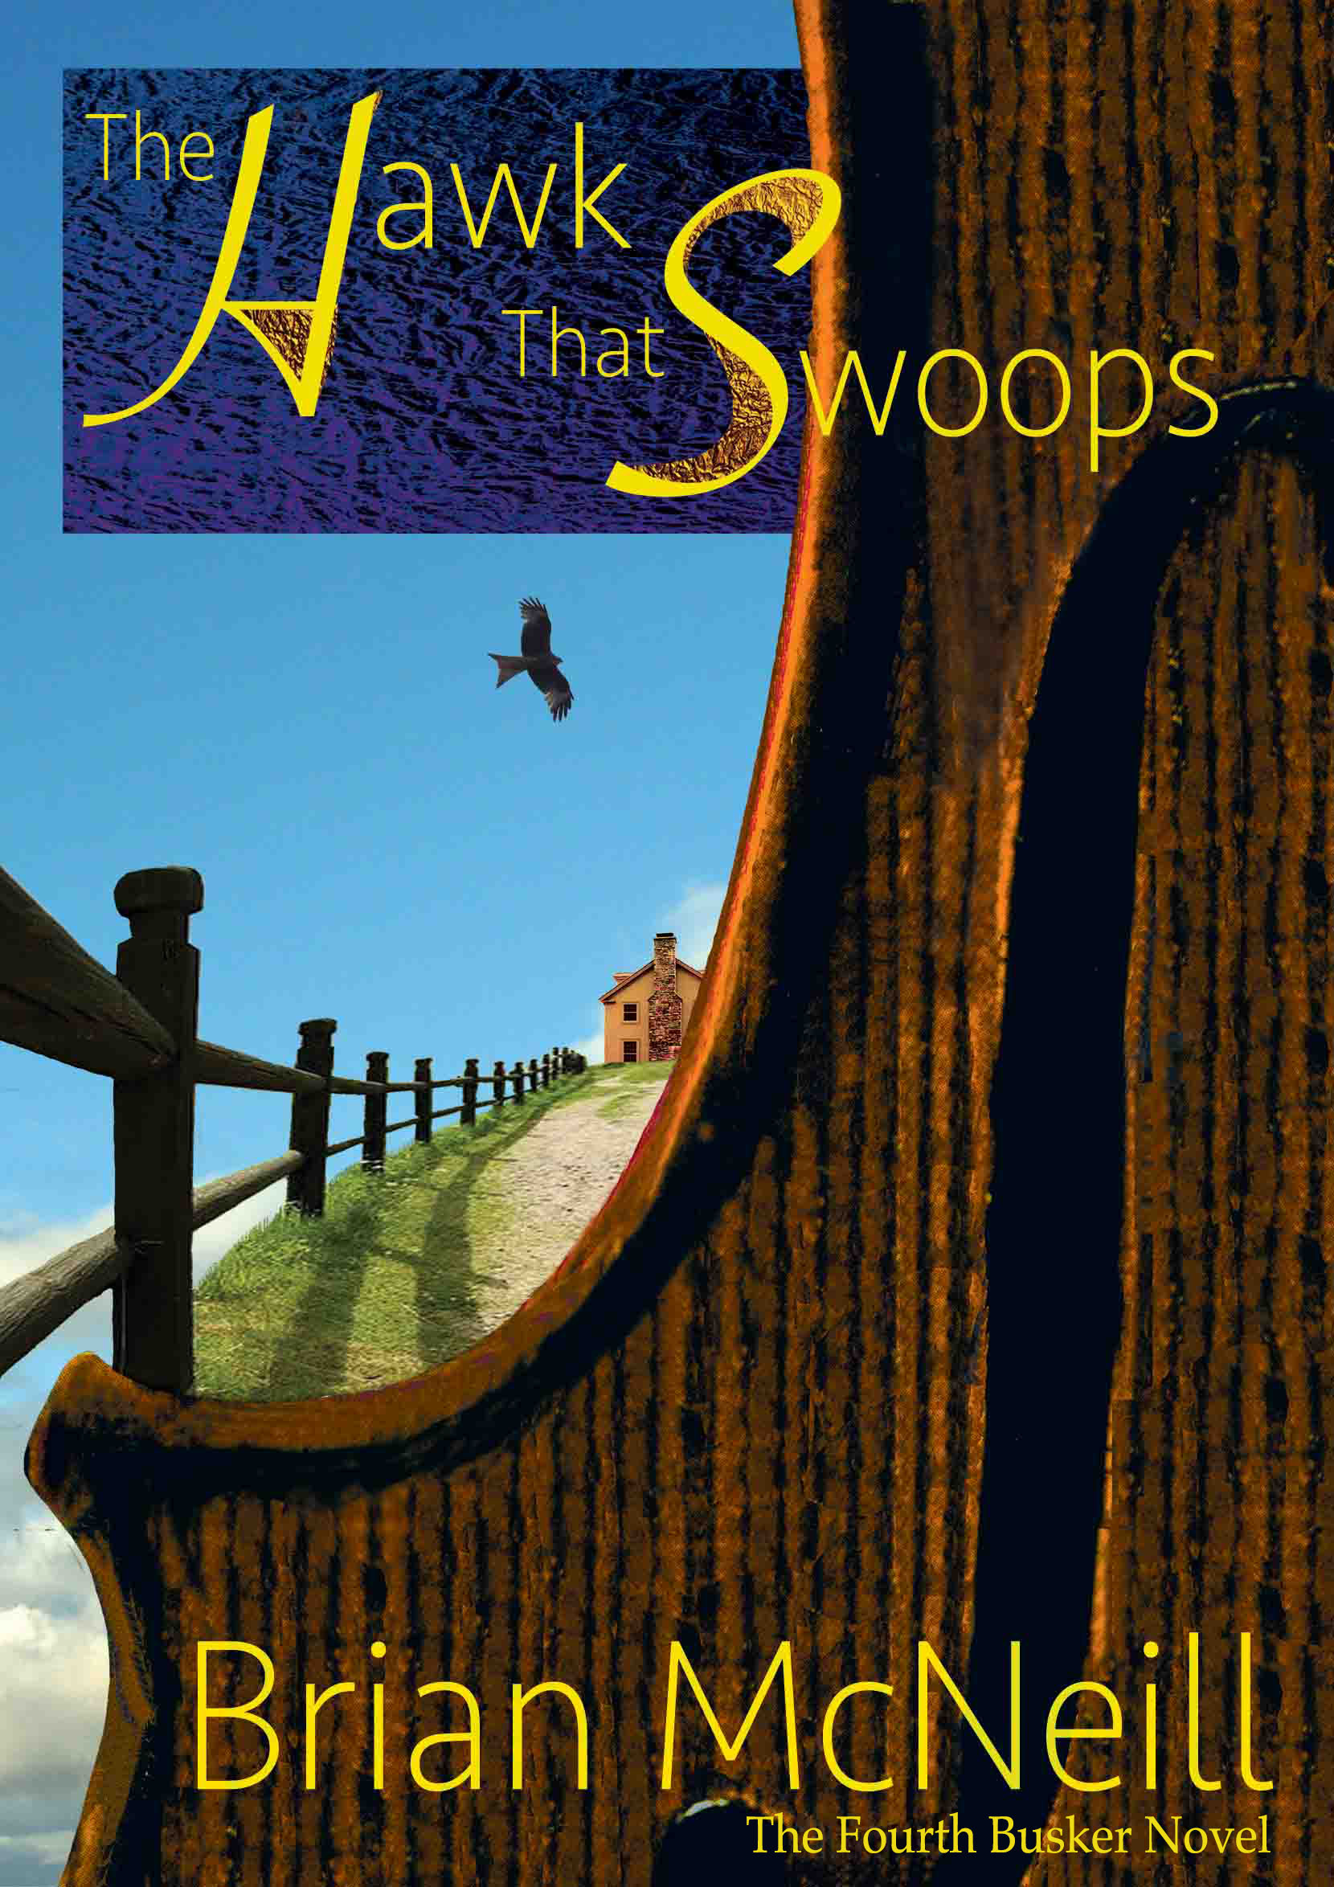
Drugs, misplaced idealism and family betrayals come to a head in Hamburg’s red light district, where Alex must make the hardest choice of his life.
THE HAWK THAT SWOOPS
Book 4 of the Busker Series

Now a witness in the counterfeit drugs case which began in No Easy Eden, Alex is in Washington DC. He’s had a letter from his father; his mother is gravely ill. Can he find an uncle he’s never heard of, in Appalachia? Due to fly out in a few hours, his visa expired, Alex knows it’s impossible.
A hotel bar fracas with a teenager brings him up against the girl’s aunt, supermodel Rose Vannier. Then, while he’s at Rose’s side in a taxi rank, a boy on a scooter tries to kill her. Alex tackles him, breaking the boy’s neck. No police, Rose insists. Why? What is she hiding? The idea of American authority’s reaction to his criminal record panics Alex into agreeing.
At Rose’s Virginia farm, he meets her entourage. They’re suspicious of him. Is he in danger? When a rattlesnake is planted in his bag, he decides to run. He steals a van, only to find Lou, the girl who started the whole thing, hidden in the back.
The busker and the streetwise kid bond—but then she’s abducted, and Alex’s van is rigged to crash. Injured as a result, he only just escapes on a freight train.
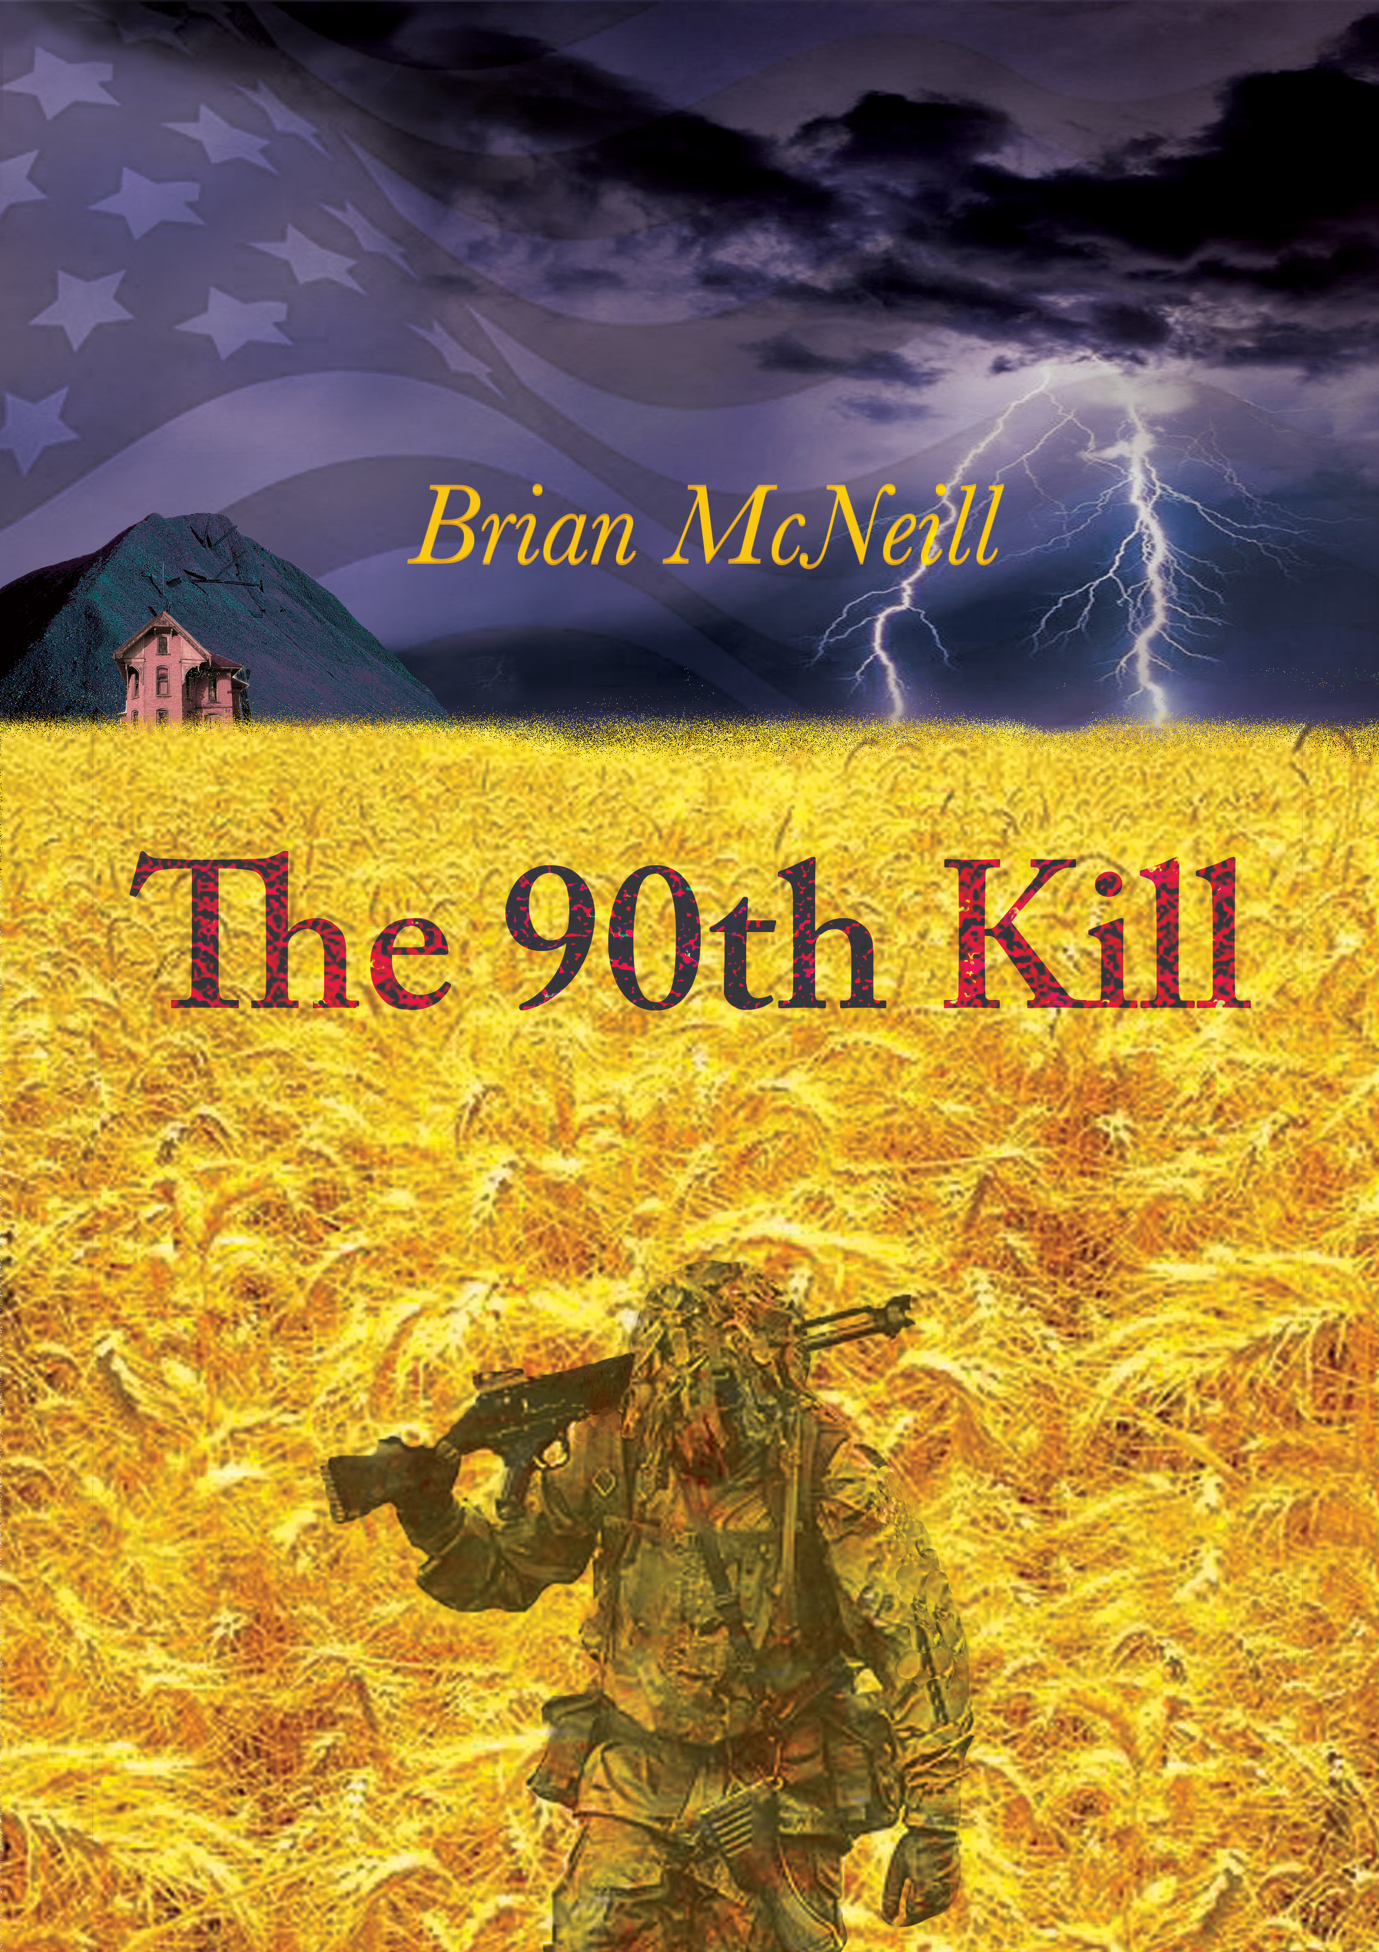
An elderly, blind Appalachian fiddler, Jane McClintock, nurses him back to health, and her humanity gives him the strength to go on, to probe the long list of convoluted lies around Rose and Lou—and to solve the sad and terrifying mystery of his own long-lost uncle.
THE 90TH KILL

All the teenager Samuel Cadogan ever wanted to do was draw—but after the death of his father, a Pennsylvania coal miner, his family explodes in a maelstrom of child abuse and violence, and he finds himself on the wrong side of the law.
He runs. For the next six years he supports himself as a sidewalk artist in Boston—and then circumstances force him to flee even further. In the US military, under his new name of Lem-uel Brecon, he discovers he has one outstanding talent. He's a world-class sniper, a natural killer.
Dishonourably discharged after serving in Iraq, burned out and barely existing on the street, he's approached by two high-ranking and high-minded ex-officers who want the re-election of a corrupt and controversial president stopped. They know Brecon's talents, and they lure him into their plot with the possibility of revenge against those responsible for his family's disintegration. Finally seduced by the promise that they will find his missing sister, he agrees to be part of their scheme. But for all their professed principles, the way these officers manipulate him is as merciless as it is cold.
This is a story about the cynicism and ruthlessness of America's elites, about the intertwined nature of its political process and its gun culture—and above all, it's about the stubborn courage of individuals and their determination to resist, to fight for their humanity as the juggernaut of American power does its pitiless best to grind them down.

I hope you find something you like!

I leave you with a picture, which I've only just found, of me and my late friend, the great Kieran Halpin, on stage together in 2012 in Boskoop in Holland.
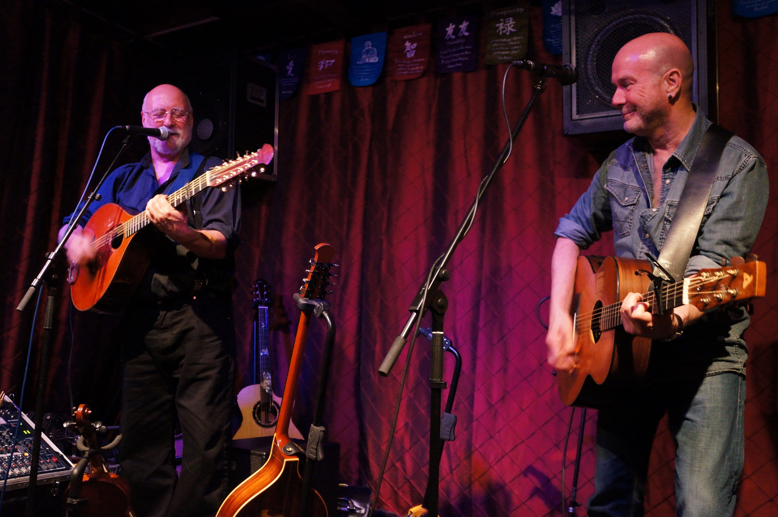

There'll be another newsletter at the beginning of April.

All the best,
