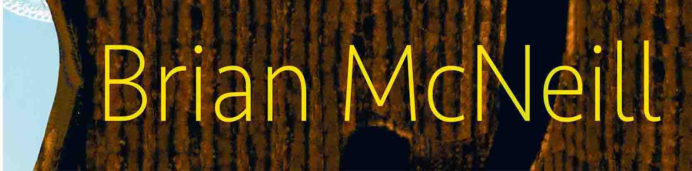

Brian’s Website

brian58@talktalk.net

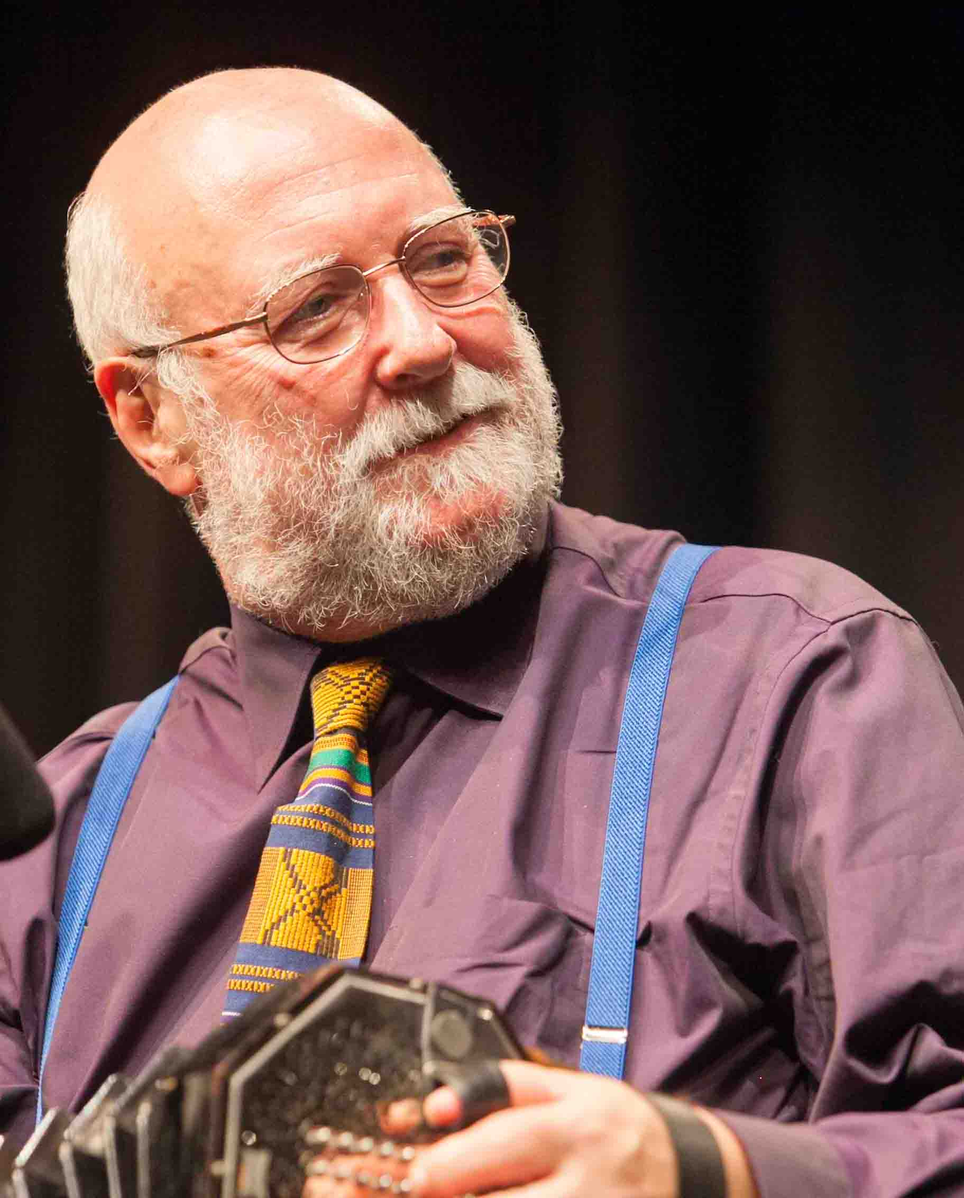
Hi folks, and I hope some version of spring is catching up with you wherever you are. If it has, enjoy it while you can, because, given the extent to which we seem to have screwed up the planet, it might well be boiling summer or freezing winter tomorrow.

I’m just managing to take a break, having been busy with the North Texas Irish Festival in Dallas, the annual Feast of Fiddles rampage through England, and The Northumbrian Gathering in Morpeth.

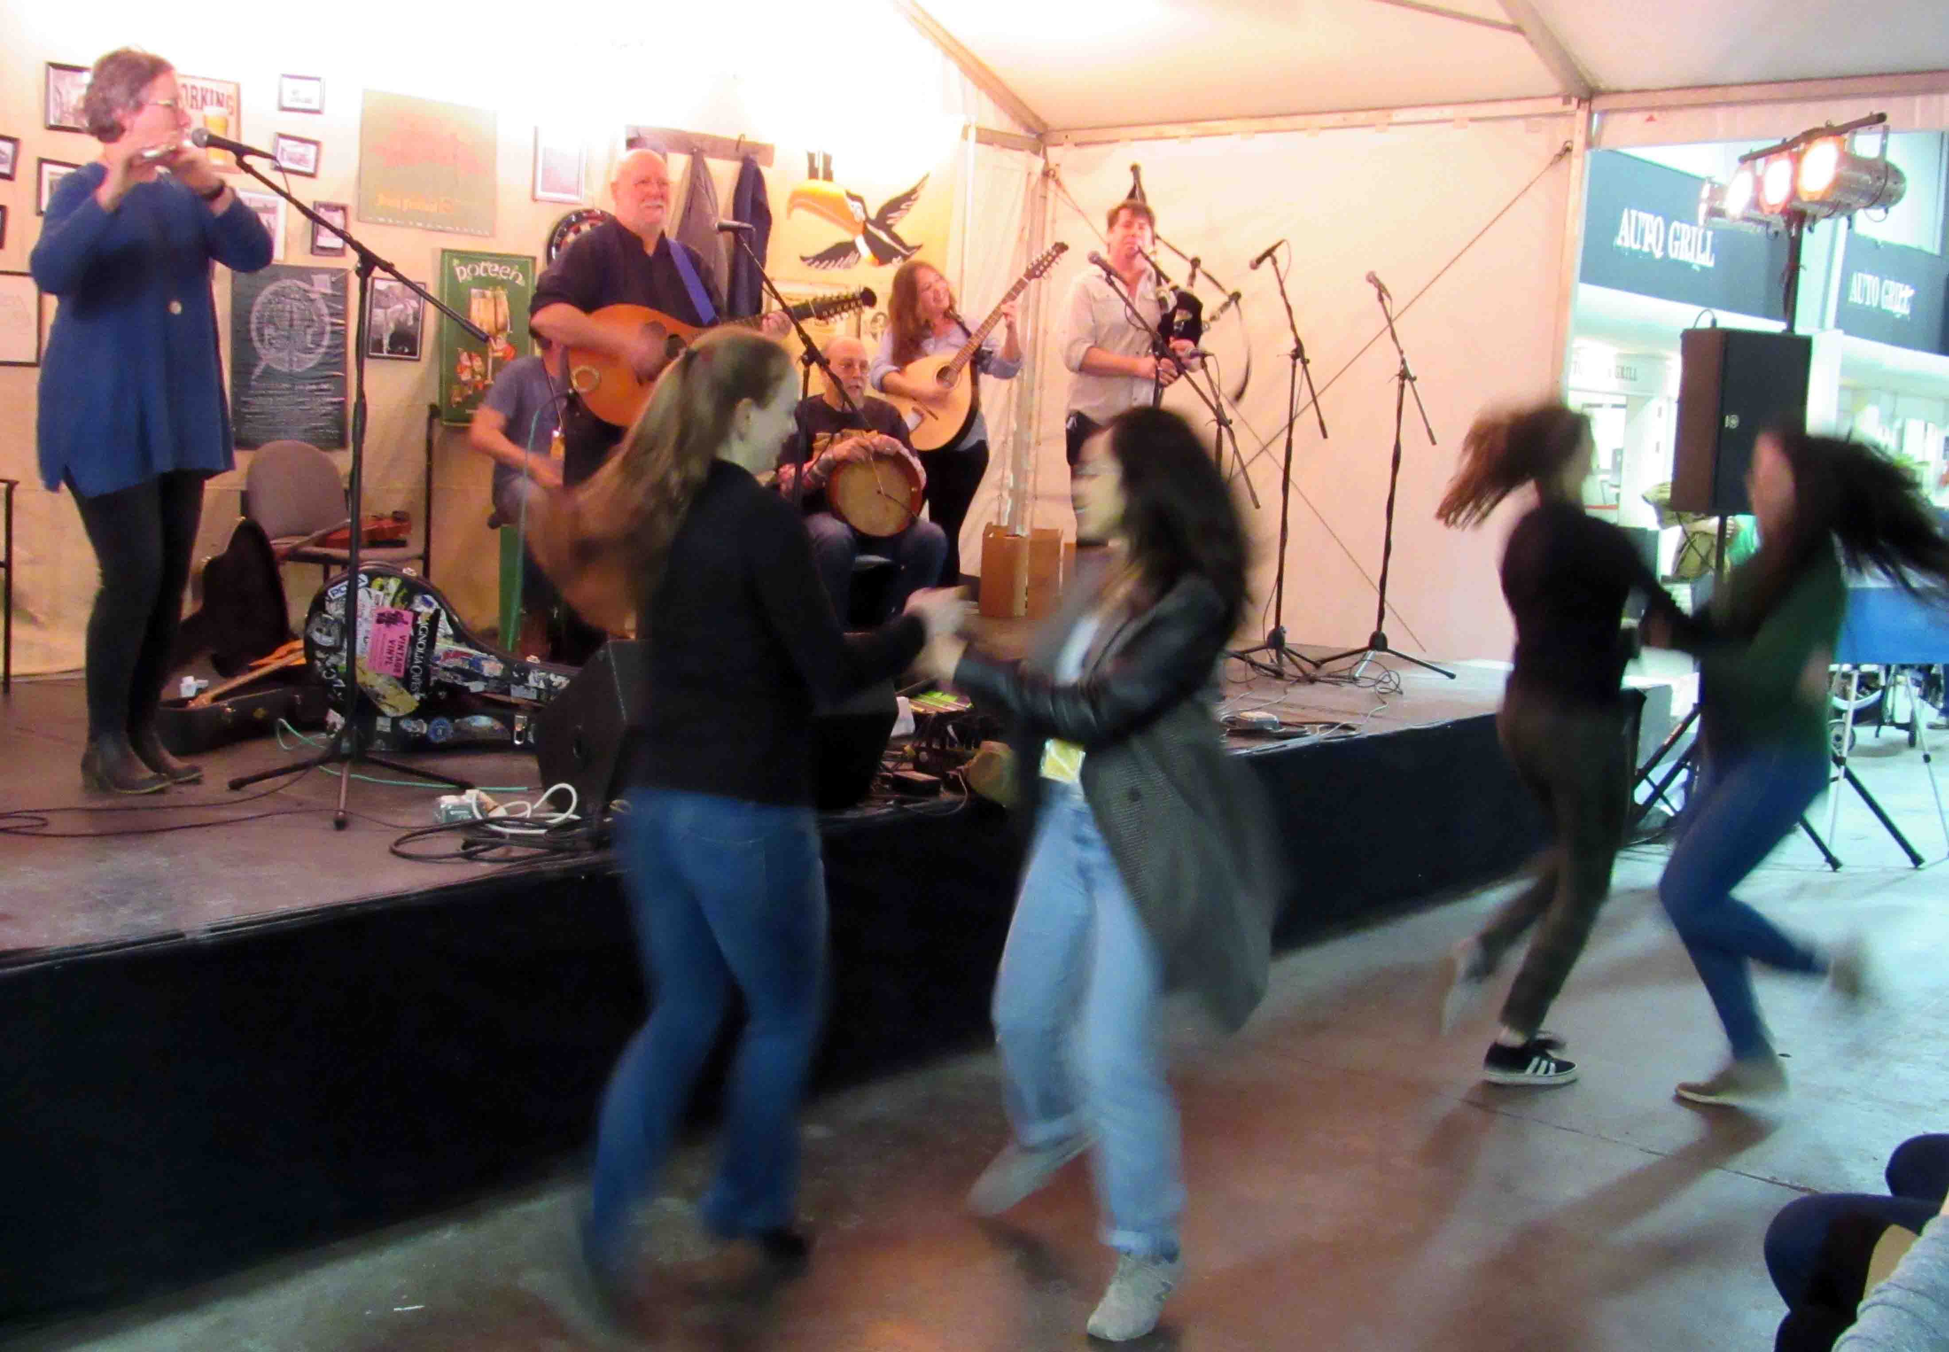
NTIF was splendid! Most of the time I played on my own, (my thanks to Sia Beaton for bringing the lovely Taylor guitar from Houston) but I appeared several times with my great friends The Wee Heavies – who made a fantastic debut at the festival - and they reciprocated by making some spirited interventions in my solo sets. One of our favourite joint numbers, a Mississippi river shanty called Rowdy Soul, brought the house down more than once. Add to that my last set, in which, as well as the Heavies, I was joined by my old friend, Dallas’s own brilliant bodhran player, Albert Alfonso, The Piper Jones Band, (E.J., Frances Cunningham and Wolf Loescher – surely the standard by which all other acoustic Celtic bands in America must now be judged) and that very fine singer and flautist Jill Chambliss, and you have the perfect example of what fun these festivals can be for musicians as well as audiences. Pipes, fiddle, bouzouki, mandocello, bodhran, flute and percussion, soaring voices... Much waving of beer mugs and some pretty wild participation – including some beautiful Irish and Highland dancing happening in front of the stage, and when I looked to the side, I saw a Star Wars trooper bopping along with a lady who wouldn’t have looked out of place in a wild west saloon - they do love a bit of dressing up at this event!

At the end of it all, an elderly lady asked me how hard it was to organise such anarchy. I confess I’m still thinking about that one…

After a great weekend, however, the morning of our departure brought sad and dreadful news, the passing of Margaret Lyle Gravitt. Margaret was a wonderful singer, drawing on both the Celtic and American traditions, with an inexhaustible fund of Appalachian lore. Her version of my own song “The Rovin’ Dies Hard” remains, in my opinion, unequalled. She was a good and lovely friend and an inspiration to many. She’ll never be forgotten, and I have no doubt her influence will continue to be felt wherever traditional music is loved.

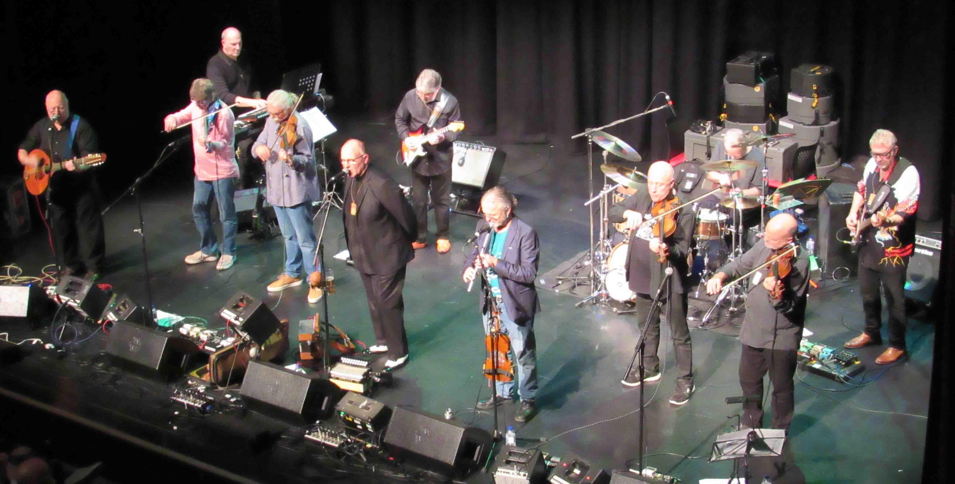
After Texas came the 25th annual tour of Feast Of Fiddles; 13 gigs, the length and breadth of England, from Hexham to Hastings.

This band is folk-rock at its most enjoyable! It started off as an experiment, a one-off gig at Nettlebed folk club in Oxfordshire a quarter of a century ago, and everyone had such a ball that it was obvious it had to be done again the next year. Then, largely due to the hard graft and dedication of our melodeon supremo Hugh Crabtree, it has grown into the sellout annual institution it now is.

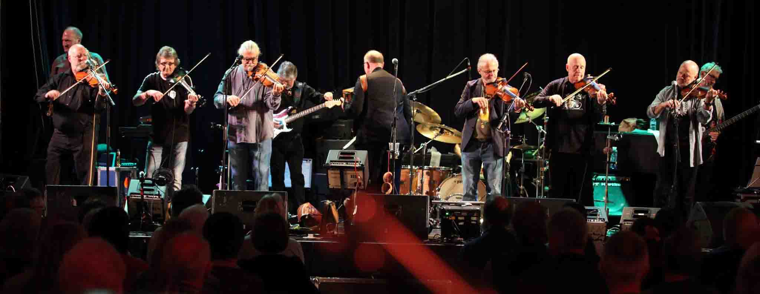
The music’s a mixture of the fiddle traditions of England, Scotland, Ireland and America, plus the stream of new compositions brought by band members. Our front line of fiddle and melodeon is rocked along by bass, drums, guitar, keyboard and sax. I won’t list all the members here – no doubt some of you will know them from the accompanying photographs (thanks to Jacqueline France and Marc Dyde) - but the band’s pedigree takes us through, among many others, The Albion Band, Battlefield Band, Bully Wee, Fairport Convention, Geno Washington’s Ram Jam Band, Lindisfarne, Show Of Hands and Steeleye Span. Our thanks to everyone who came out to see us, we hope you had as good a time as we did, and that we’ll see you all again next year – and perhaps at the odd festival this summer, watch this space.

On the evening of April the 27th, I played at the winners concert of the annual Northumbrian Gathering in Morpeth, after being given the honour of helping judge the afternoon instrumentalist and band competitions – and I’m pleased to tell you that the standard of the entries was very high. It’s always a pleasure for me to participate in this event, a genuine grass roots music festival - not least because the fine tunes of this region have been part of my repertoire since I first encountered them back in 1976. Huge thanks to Kim Bibby-Wilson and all her team, for their hard work and never-ending organisational patience.

Next up, a long-anticipated tour of Denmark and Germany with Rod Sinclair, which I’m really looking forward to. I also hope to have enough time to get my new CD, No Silence, completed and released.

On the writing side, I’m busy with the organisational work involved in getting two of my new novels ready for publication. Once that’s done, I can get on with designing the covers, which I must confess, is a pure joy. As someone whose high school attempts at art were always received with either lofty contempt or a gently pitying smile, I now take huge pleasure in the artwork side of things, both for my books and my cds. There’s something incredibly satisfying about being able to show the finished result of my own work in exactly the way I want.

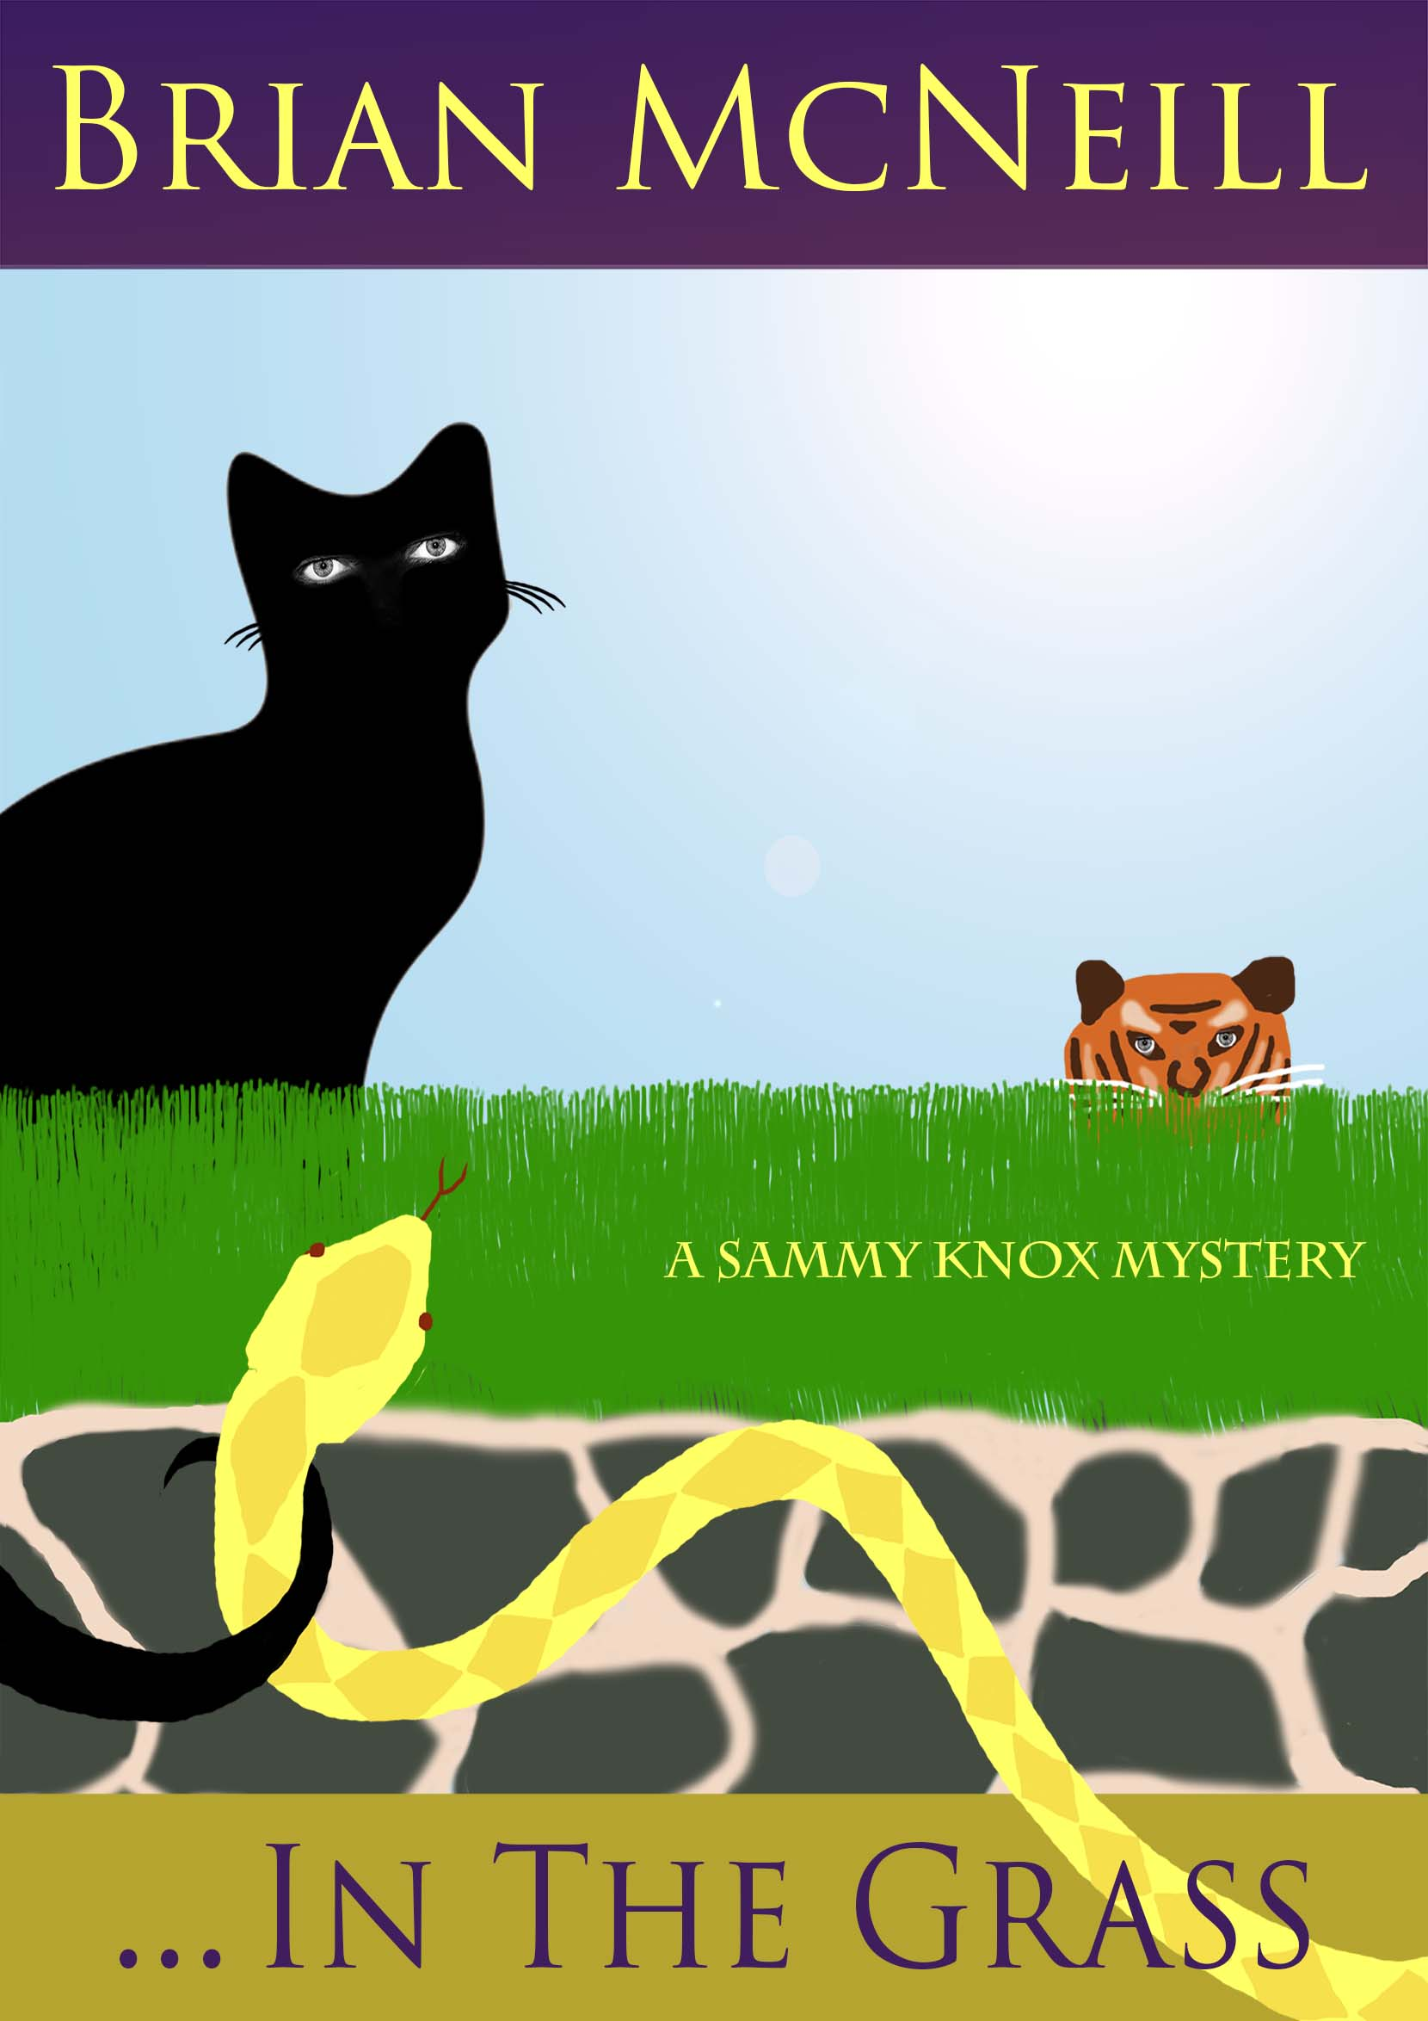
The other writing news is that my collection of short fiction, The Horseman’s Word and Other Stories, due out this summer, will be published in both eBook (Amazon and Apple Books) and paperback format, and in both English and German. Some of my Scottish readers have expressed surprise at the decision to include a glossary, but it seems to me that making Scots words accessible to those who don’t understand them is an obvious plus - I want my readers to be moved by what I write, not mystified or frustrated by it. Paperbacks in both languages will be available through my website.

By the way, I do enjoy hearing from those who've read any of my novels or listened to any of my CDs. It was a pleasure to receive a review of …In the Grass from Carol Hird in Chatham, which I include below - and if you feel so inclined, I'd love to receive your thoughts on my books or my music. My thanks to Carol for allowing me to share her views, but of course if you'd rather I didn't publish what you send, just let me know.

“Sensuous, cunning super-sleuth Sammy Knox is unmatched in the detective genre. Brian McNeill’s brilliantly crafted story and fantastic cast of characters will transport you to another dimension from the very first page. Pure magic!”
Carol Hird
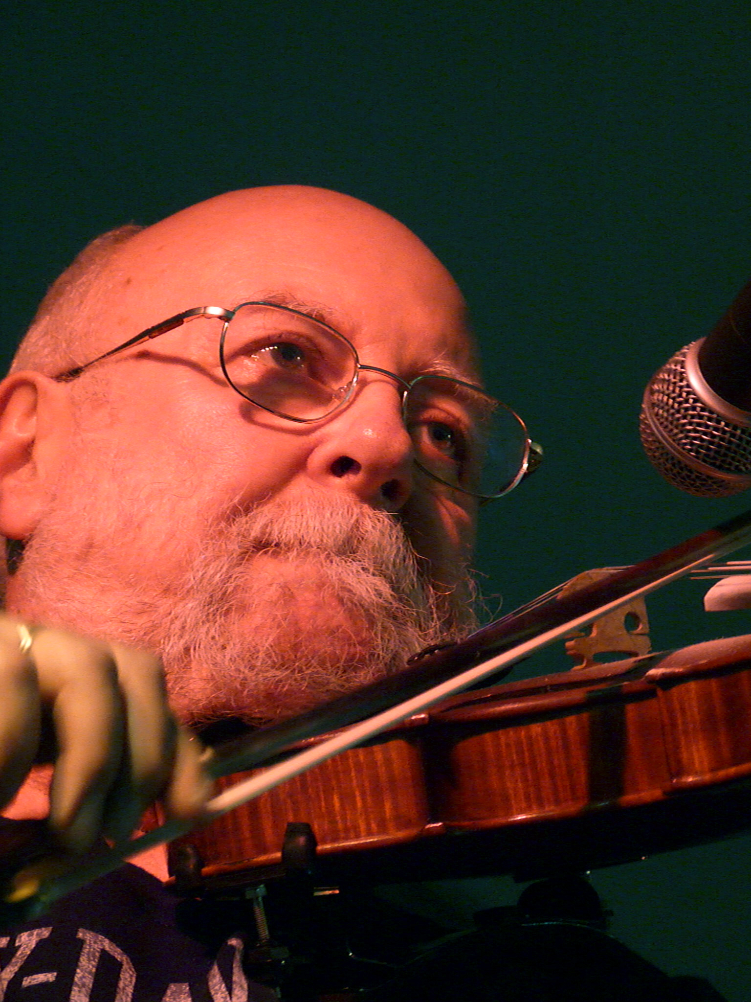
Finally, as I said in my last newsletter, this mailing list hasn’t been put together by simply trawling for addresses - everyone has been asked if they would like to be here. If you decide you no longer wish to be included, please let me know. And if you know anyone you think might like to be added, please ask them to email me at the above address.

I’d enjoy hearing back from you.

All the best,

